**Enhancement Three: Databases**

**CS-499 Computer Science Capstone**

**Juan Topete**

**06/15/2024**

The artifact I chose for this category is the Grazioso Salvare – Animal Shelter dashboard from CS-340 Project Two. This was a project that used Python and MongoDB as the database framework. The main py file is called AnimalShelter.py and contains code for the CRUD: Create, Read, Update, and Delete functions. It also initializes the MongoDB accessing the animal shelter records. The main interface is stored on the .ipynb file which sets up the widgets for the interactive dashboard. The interactive menu options are used to filter the Austin Animal Center Outcomes data, a data table which dynamically responds to such filtering options as a pie chart, and a geolocation chart containing the location of the shelter. As shown in the image below, the code runs the header first opens the logo image stored in the same directory as the application and then displays the widgets which display data pertaining to the records of the animal shelter.

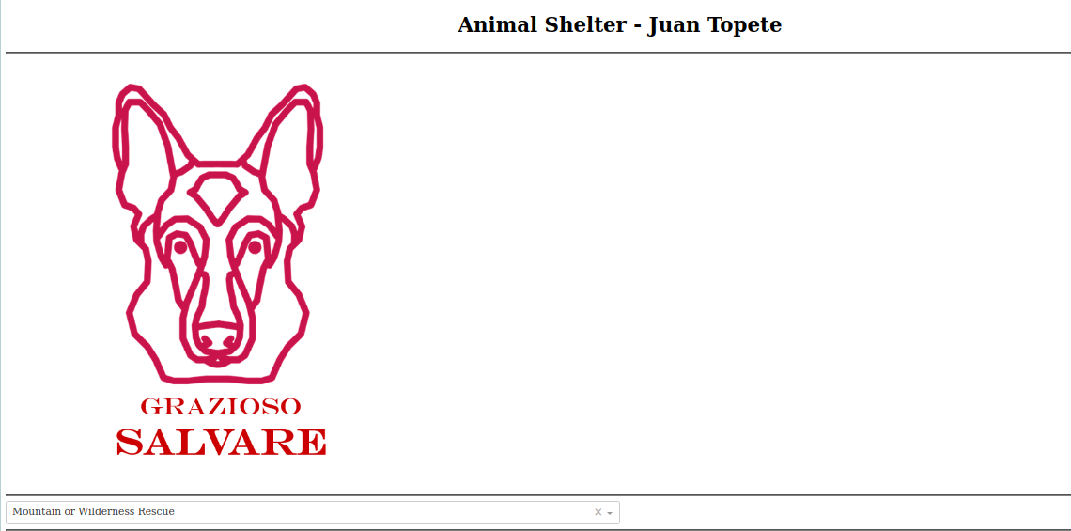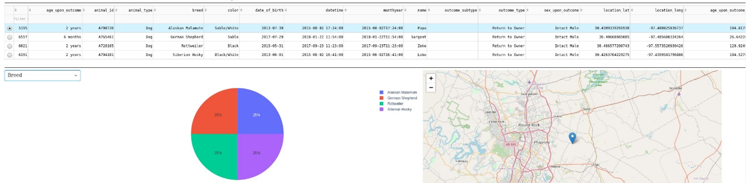

I selected this artifact as it had a lot of different tools available to improve the appearance of the application. The application also could have been expanded to include different sorts of data to make the application accessible to a larger audience. I decided to also rework the CRUD module to improve readability and replace unnecessary code.

Some of the challenges I had to overcome were present when I first done the project originally and included elements not showing up on screen. I overcame the challenges by having regular testing sessions and rewriting small sections to see what area was causing the problem. I adjusted several parameters to change the layout of the menu to modify its look. This way the interface is better suited to meet user needs.